InkStormer

[Company name] | [Company address]

[Document subtitle]

By john brice

[Year]

Contents

Analysis 2

Problem Identification 2

Computational Methods 2

Stakeholders 2

Research 2

Website 1 2

Website 2 2

Website 3 2

Essential Features 2

Limitations 2

Hardware And Software Requirements 2

Success Criteria 2

Design 2

Decomposition 2

Explanation of the process 2

Solution structure 2

Iterative development 2

Example 2

Post development testing 2

Testing 2

Usability testing 2

Evaluation 2

Success criteria 2

Unmet criteria 2

Usability features 2

Maintenance issues 3

Limitations 3

# Analysis

## Problem Identification

In 3D design and modelling, Displacement maps and normal maps are used to ‘displace’ 3 dimensional meshes. They add surface detail without requiring more vertices in the mesh. This means models require fewer vertices to get the same detail. This means models using this technique take less memory and storage space. These maps are often made with types of procedurally generated noise layered on top of each other. These are saved as bitmaps. Normal maps are superior to displacement maps, as they use the RGB colour values to displace values in XYZ. Most 3D programs support some types of noise, but these mostly run on the CPU and cannot run in real time. Noise generation is evaluated per pixel, so it is a good candidate for GPU processing, as each pixel can be evaluated on a different core.

## Computational Methods

## Stakeholders

Ben Wigley:

Ben uses Blender to do his 3D modelling in his free time. He frequently uses displacement and noise maps while modelling. He is limited by his laptops CPU processing power, and needs the program to run efficiently on his NVIDIA graphics card. He needs a free program with customisable noise size and detail, and needs to be able to save the bitmaps in different resolutions. He also wants comprehensive online documentation in case he forgets how the software works, as he will not be using it every day.

Alfie Bacon:

Alfie is a professional 3D animator and filmmaker at a local company. He mainly uses Blender and Unreal engine. Blender has comprehensive options for noise generation, but Unreal Engine lacks variety and customisability in its noise. Due to production workloads and deadlines, he needs to be able to efficiently produce and manipulate 8K textures. The software also needs to be able to utilize his NVIDIA graphics card. Due to the nature of his work, he needs to be able to save and load project files for customisation later. For best detail, he needs to be able to save files as 16-bit greyscale heightmaps. He uses an ultrawide monitor and would like to be able to adjust the user interface to fit.

### Takeaways from stakeholder interviews

* Must run in real time.
* Must have easily configurable noise settings.
* Must be able to save bitmaps in varying sizes.
* Must Utilise NVIDIA acceleration hardware.
* Must have a file format to save projects.
* Must be able to export to 16 bit PNG

## Research

### Software 1 - Blender

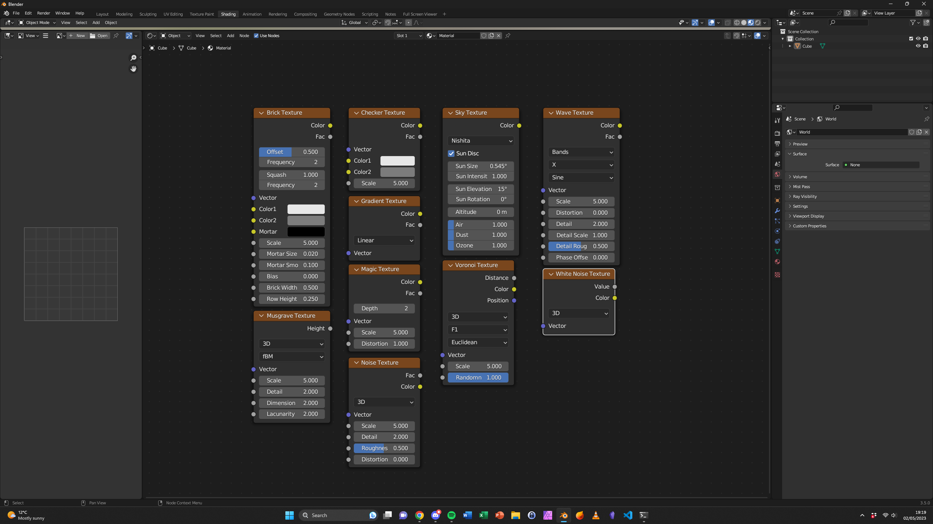

Blender is a free piece of software that has many different options for generating noise. The node-based user interface makes it very powerful but can be hard for beginners to master. Connections can be dragged between nodes, allowing quick development. The colour coded connections prevent any erroneous connections, making it quite user friendly. However, the online documentation is very scarce and non-intuitive. This is something I will strive to address with my project. The slider inputs also allow easy modification of input values. One problem with Blender is that it evaluates the nodes on the CPU, which can lead to slow response times on detailed models. I hope to address this by running my code on compatible NVIDIA graphics cards with the CUDA toolkit.

### Website 1

<https://core.ac.uk/download/pdf/250147208.pdf>

This paper talks about the methods behind generating noise, and how they can be used in video games to generate terrain. The methods explained in the paper will help when designing the back-end functionality of the program.

### Software 2 – Awesome Bump

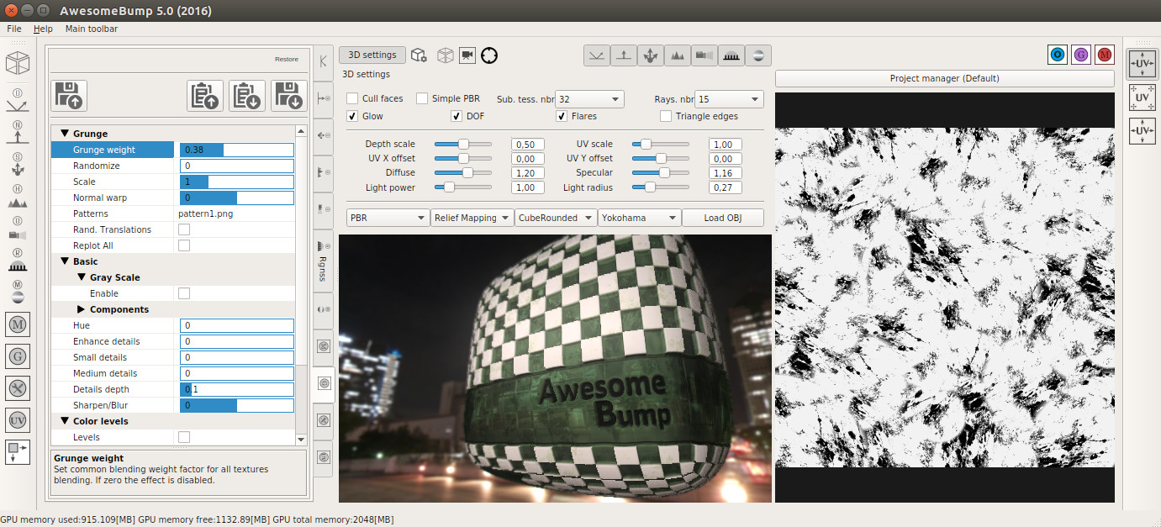

AwesomeBump is open source and is similar to my goal. The sliders look intuitive to use, so I think I will use a slider-based approach to customisation. I think I will make the texture view bigger so that it is clearer. I don’t think I will be able to achieve the 3D view, so the texture view can take up more space. Unfortunately it can only manipulate existing textures, and does not have the tools to generate its own noise textures.

### Software 3 - Imogen

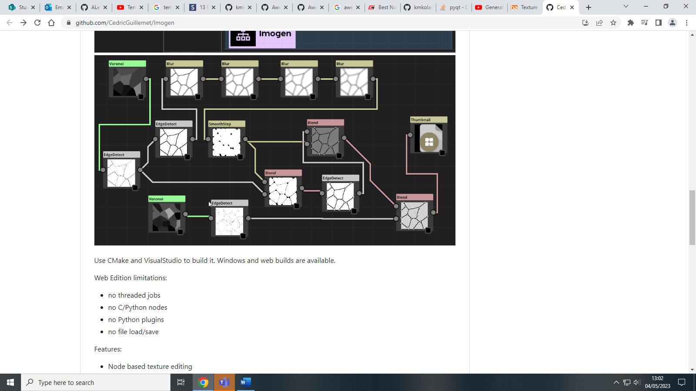

Imogen uses a variety of nodes to generate noise and combine it. The user interface seems easy to use, but the lack of customisation of the nodes looks limiting. The project has also not been maintained since 2019.

### Essential Features

## Limitations

## Hardware And Software Requirements

## Success Criteria

# Design

## Decomposition

## Explanation of the process

## Solution structure

## Iterative development

### Example

#### Introduction

#### Algorithm

#### Variables and data structures

#### Identify test data

#### Coding

#### Testing

#### Failed test fixes

#### Evaluation

## Post development testing

### Testing

### Usability testing

# Evaluation

## Success criteria

## Unmet criteria

## Usability features

## Maintenance issues

## Limitations